Lab 10: The Milky Way

Goals
- Use astronomical data to create a model for the Milky Way.
- Use the model to determine the location of the center of the Milky Way (both its direction and its distance from Earth).

Resources
Messier Object Info: http://messier.seds.org/Messier.html
List of Messier Objects: https://en.wikipedia.org/wiki/List_of_Messier_objects
List of Globular Clusters: https://en.wikipedia.org/wiki/List_of_globular_clusters

Essential Knowledge
The Sun is one of over 250 billion stars in the Milky Way galaxy. Our galaxy is considered to have three main components: Disk, Bulge, and Halo.

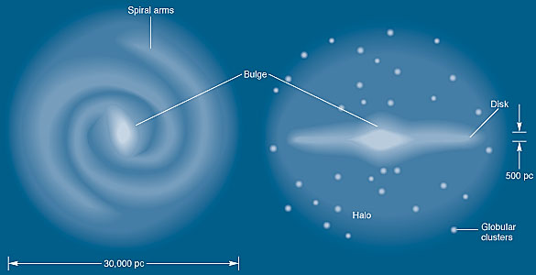
Disk: spiral arms, rich in gas and stars.

Bulge: central region that has a more spherical/elliptical shape.

Halo: Surrounding material gravitationally bound together. Globular clusters are found here.

Think About It
Determine in what part of the galaxy the Sun must be located to see the Milky Way as we do. E.g. what does the band of the Milky Way in the sky correspond to physically?
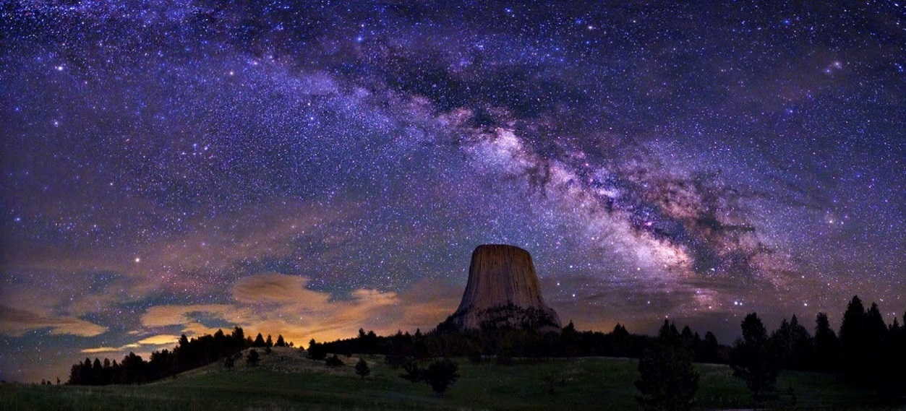

Think About It
Here we will recreate work similar to that done by Harlow Shapley in the 1910s and 1920s in order to figure out the location of the Sun in the Milky Way galaxy. The crucial idea he had was to use globular clusters as a way to determine the center of mass of the Milky Way. These clusters are tightly bound together by gravity, and they are very old. Their motion should be dominated by the mass of the Milky Way, and thus the globular clusters should be centered around the Milky Way’s center of mass. His work measured direction and distances to many globular clusters to determine where the center of the Milky Way is, and our location with respect to it.

Work On It
Use the resources provided to find the distances and directions to at least 15 globular clusters. Then use the simple model at the end of the lab to graph your results. Consider Earth/Sun to be at the central “X”, and the ring of constellations as a guide to the direction of the globular clusters. Use a scale of about 1cm = 5,000ly to place points on your graph that match the position of the globular clusters. Once you have placed all your points, visually estimate where the center of the globular clusters is, and mark that location as the center of the Milky Way. Determine the direction and distance to the galactic center from Earth by measuring the distance from the X in the middle to the location of your estimate for the center of the Galaxy. Use your scale to convert back into kilolightyears ! Use the constellation names to describe the direction to the center. (e.g. the center is 40Klyr away in the direction of Orion)

Lab Report Requirements

Intro: Describe the general features of the milky way and introduce the idea of finding our location in it.
Method: describe what data you will use, and how you will use it to make a simple model of the milky way.
Data: Show your data on the globular clusters and your graph of the results
Conclusion: Use your data to estimate the direction and distance to the center of the Milky Way. Look up the accepted values and discuss how your results compare.

Constellations of the Milky Way

Canes Venatici
Ophiucus Serpens Coma Berenices
Aquarius Sagittarius

Hercules Scorpius
Capricornus Scutum
Sagita

Lyra Norma/Circinius
Aquilla

Centarus/Crux

Pegasus

Cygnus X Vela
Hydra

Cepheus Puppis

Cassiopia Canis Major
Lepus

Perseus Orion/Gemini

Auriga

Globular Cluster Name | Direction (constellation) | Distance (Kly)

